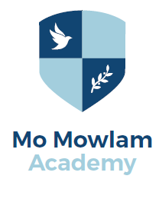
Year 7 Catch-Up Premium Report 2018-2019

The DfE has made additional funds available for improving the attainment of our disadvantaged pupils. This grant is known as the Year 7 Catch-Up Premium. The funds are primarily aimed at improving Maths and English levels at key stage 2 (KS2). An allocation is made for every pupil who has not achieved the ‘expected standard’ in reading or maths at KS2 as per the October school census.

This short report summarises how the previous year’s funding was spent and how we intend to spend this year’s funding. Most importantly, it provides information on the outcomes of the spending and the improvements made amongst our pupils.

Total amount received 2018-19: £6000
This funding was used to purchase software to engage students and develop their literacy and numeracy skills, including IPADS; Nessy; My Maths; Maths Whizz. We also invested in the Learning Ladders assessment tool allowing students to work through specific gaps in their learning to make progress.

Total amount allocated for 2019-20: £3,500
This money will be spent on further developing literacy skills through the use of Lexia; resources to support early entry for Entry Level qualifications to boost self-esteem; 1:1 interventions to support rapid progress in maths and English.

